**CH 245: ORGANIC CHEMISTRY 1 LABORATORY (Fall 2019)**

**Title:**

1. **Purpose: (1 point)**

The purpose of this experiment is to understand the method of measuring boiling point of a compound to determine the purity of a solid organic compound. This experiment will also introduce a new piece of lab equipment: the Mel-Temp.

1. **Drawing of structure of the main compound or balanced chemical equation if synthesis is performed: (1 point)**

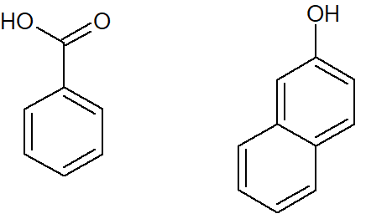

Benzoic Acid 2-Napthol

**3. Reagents and the major product (up to 6 points)**

|  |  |  |  |  |  |  |
| --- | --- | --- | --- | --- | --- | --- |
| **Name** | **M.W.**  (0.5 pts) | **Density**  (0.5 pts) | **Amount (grams/mL)**  (0.5 pts) | **Moles**  (0.5 pts) | **Hazards/Precautions**  **(MSDS data) and melting point or boiling point** (2 pts) | **Waste Disposal**  **(aqueous or organic)** (2 pts) |
| Benzoic Acid | 122.12 | 1.27 g/cm3 | N/A | N/A | Skin and severe eye irritation, M.P. 122.41 °C | Organic |
| 2-Napthol | 144.17 | 1.22 g/cm3 | N/A | N/A | May cause skin and eye irritation, M.P. 120-124 °C | Organic |

**4. Procedure (up to 2 points)**

|  |  |
| --- | --- |
| **Procedure** | **Observations and Lab Data** |
| A summary of the procedure done with bullet points) | Color changes, exothermic or endothermic reactions, gas generation, etc.; tare weights for flasks, etc. |
| * Prepare a powder sample of crystallized benzoic acid or other crystal mixture. * Place small amount of sample into capillary tube (1-3mm in length) by putting open end of tube into the powder, inverting the tube, and tapping powder to bottom of the tube. * Place tube and thermometer into Mel-Temp and turn on the heat. * Apply moderate heat and make a moderate approximation of the melting point. Record approximate temperature. * Prepare another sample in the same manner but heat slowly up to approximate melting point, around 15-20 degrees Celsius below. * Continue heating at 2 degrees Celsius per minute and record temperature when substance begins to melt. * Record temperature again when substance is completely melted. |  |

**5.** Results; include actual yield in grams and % yield.

**Results (need to get signed by instructor or TA):**

|  |  |  |
| --- | --- | --- |
| **Sample** | **Melting Point**  **(first run)** | **Melting Point**  **(second run)** |
| **Recrytallized Benzoic acid**  **(from Exp-1)** |  |  |
| **100% Benzoic acid (Pure)** |  |  |
| **100% 2-Naphthol (Pure)** |  |  |
| **90% Benzoic acid and 10% 2-Naphthol** |  |  |
| **50% Benzoic acid and 50% 2-Naphthol** |  |  |
| **10% Benzoic acid and 90% 2-Naphthol** |  |  |